Village Government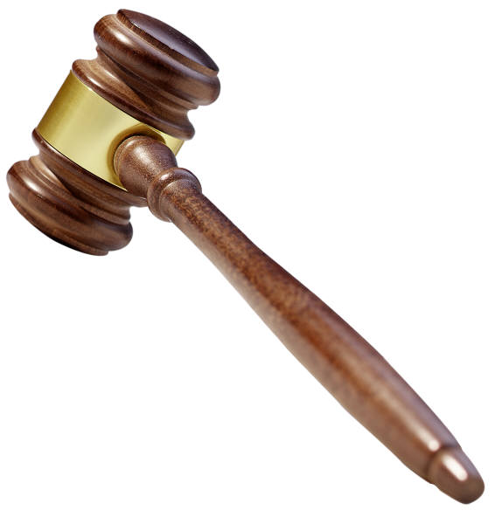
The Village of Birch Run is governed by a Village President and four Council Members. There is also a DDA Director/ Village Manager, Village Treasurer and Village Clerk. The Village Council meets the fourth Monday of the month at 7 p.m. in the Council Chambers, located in the Village Offices.

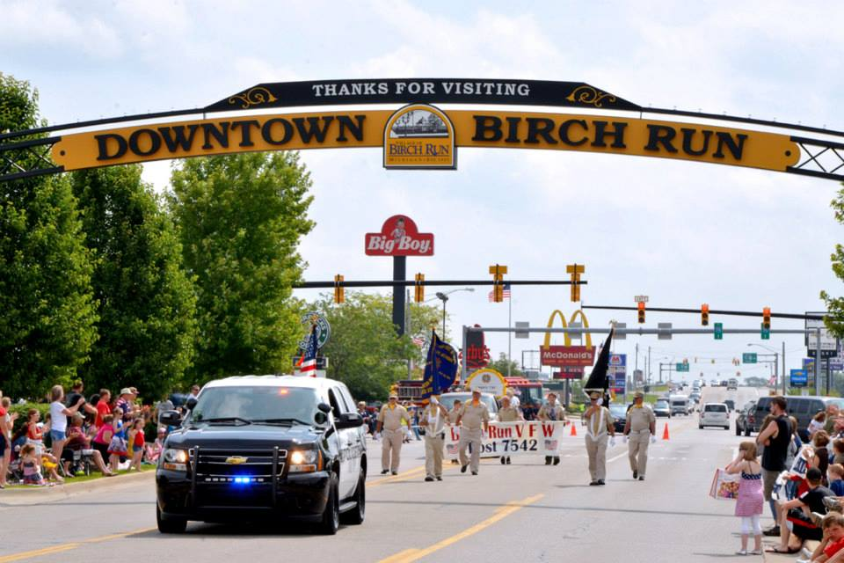

Downtown Development Authority
The Village has a DDA which meets throughout the year. Please visit the Village’s website for the meeting schedule and any additional DDA information.

Permits 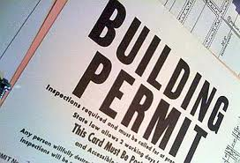
All new businesses are required to get a Basic Building Permit. Inspections are made of the fire alarm system and all exit lights. Businesses can open after receiving their Certificate of Occupancy. Any new or current businesses making renovations, including sign installations, should assume permits are required. Please contact the Building/Zoning Administrator at (989) 624-5711 before improvements are made. Permit applications can also be found on the Village’s website under the Building/Zoning section.

Business Licenses
All businesses are required to have a current business license issued by the Village of Birch Run. This license is renewable on an annual basis. Current businesses receive a renewal notice mid-October, with due date being January 1st. Once payment and completed application are received by the Village, an inspection is made. Upon approval, a business license certificate is issued. If a business has completed the necessary steps and has not received a renewed license by the end of February, please contact the Village office.

Rental Housing Licenses 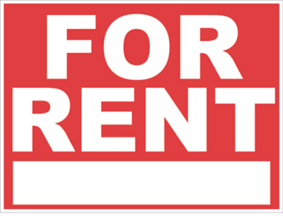
All Rental Houses are required to have a rental license issued by the Village of Birch Run. This is renewable on an annual basis. Rental owners are sent a renewal notice mid-October for the following year. Please complete the application and make payment to the Village prior to the due date. Upon submission of application and payment, an inspection is made. Once approved a rental license certificate is issued.
Tax information 
The Village of Birch Run tax bills are sent out on July 1st and are due date August 31st. Tax bills are payable at the Village office, by mail, online, or drop box.
Refuse Services 
Businesses located in the Village are expected to arrange refuse services through their own individual contracts.


Department of Public Works
The DPW is responsible for streets, sewer, and water services as well as general upkeep in the Village. For all after hour DPW emergencies, call (989) 624-9856.
Snow Removal
Annually, business and rental property owners receive notification of the local policies and state laws regarding snow removal. This information is mailed with the license renewal applications. The Village DPW appreciates your cooperation in notifying your snow removal contractors of these laws and policies.

Village Utilities
As a new business, please contact the Village to set up a new utility account. A utility deposit is required in setting up this account. Please note that the Village of Birch Run offers a quarterly utility bill that includes water and sewer. Bills are sent out on a quarterly basis; January, April, July and October. Bills can be paid in person at the Village office, by mail or online. There is also a convenient drop-box located by the front door. A late payment charge is added to bills past due.
Fire and Police Department 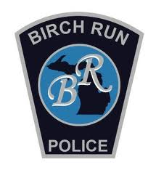
The Village of Birch Run is protected by the Birch Run Township Fire Department and the Birch Run Police Department. In case of an emergency, dial 911.

Chamber of Commerce
The Village of Birch Run has an active Chamber of Commerce. Businesses are encouraged to contact the Chamber at (989)624-9193. A complete listing of area businesses, organizations, and healthcare can be found at www.birchrunchamber.com.

Useful Ordinances

Anti-Blight
- Property owners are responsible for maintaining their property to safety and appearance standards.

Weed, Tall Grass and Tall Brush Control
- Starting May 1st of each year property owners are required to remove all tall weeds and grass from their property and the right of way in front of their property. Tall weeds and grass is anything over 9”.

Traffic Control
- Parking between the hours of 3 a.m. and 7 a.m. is prohibited on all streets and in Village owned parking lots.



Home of the Panthers!
Birch Run Area Schools:
Administration
(989) 624-9307
Birch Run High School
(989) 624-9392
Marshall Greene Middle School
(989) 624-5821
North Elementary School
(989) 624-9011
www.birchrun.k12.mi.us

Useful Information
Birch Run Fire Department:
(989) 624-9561
Birch Run Herald:
1-800-352-1919
Birch Run Police
(989) 624-1113
Birch Run Township:
(989) 624-9773
Chamber of Commerce:
(989) 624-9193
Consumer’s Energy:
1-800-477-5050
U.S. Post Office:
(989) 624-5324
Saginaw County Treasurer:
(989)790-5225
www.saginawcounty.com
Saginaw Future
(989) 754-8222

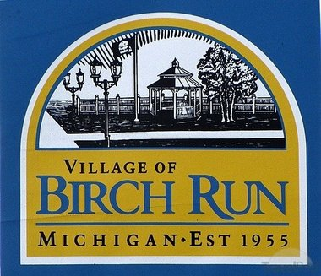

Village of Birch Run
12060 Heath Street
P.O. Box 371
Birch Run, Michigan 48415
Phone (989) 624-5711
Fax (989) 624-9681

Village Office Hours
Monday-Thursday 8-12; 1-5
Friday 8-4
www.villageofbirchrun.com
Visit us on Facebook

Vision Statement
The Village of Birch Run is a community that is beautiful, historic, culturally diverse, affordable, safe, and well planned with great opportunity for our citizens.
