
Birch Run was originally founded as a station on the Pere Marquette Railroad by John Moore, its first postmaster, in 1852. It was named after its creek, which runs through a large birch area. In 1863, the town was renamed Deer Lick and remained so until 1868 when it reverted back to Birch Run. Birch Run was incorporated as a village in 1955.
Village Government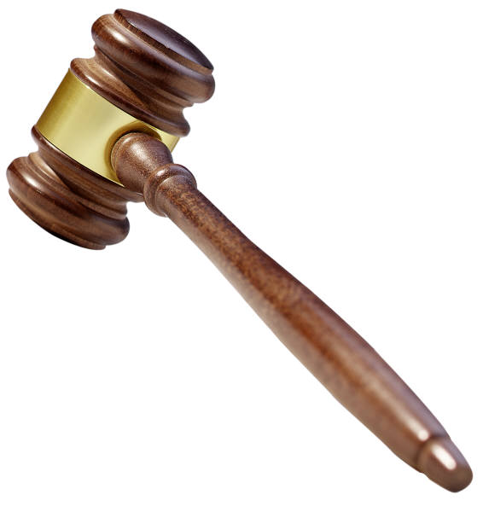
The Village of Birch Run is governed by a Village President and four Council Members. There is also a DDA Director/ Village Manager, Village Treasurer and Village Clerk. The Village Council meets the fourth Monday of the month at 7 p.m. in the Council Chambers, located in the Village Offices.

Fire and Police Department 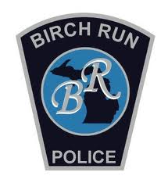
The Village of Birch Run is protected by the Birch Run Township Fire Department and the Birch Run Police Department. In case of an emergency, dial 911.

Department of Public Works
The DPW is responsible for streets, sewer, and water services as well as general upkeep in the Village. For all after hours DPW emergencies, call (989) 624-9856.

Voting Site 
The Village of Birch Run is voting Precinct #2, Saginaw County District 7. The polling location is at the Knights of Columbus Hall located at 11105 Dixie Hwy, Birch Run.
Village Utilities
The Village of Birch Run offers a quarterly utility bill that includes water and sewer. Bills are sent out on a quarterly basis; January, April, July and October. Bills can be paid in person at the Village office, by mail or online. There is also a convenient drop-box located by the front door. A late payment charge is added to bills past due.

Payment Plans
The Village of Birch Run makes every effort to work with residents regarding payment of their utility bill. If you are having difficulty with payment, please contact the Village office to make a payment plan arrangement. The final payment must be paid prior to the next utility billing cycle. The late payment penalty will be part of the payment plan arrangement.

NSF Fee
If a check is returned for non-sufficient funds or a closed account, there will be a $25 processing fee.

Tax information 
The Village of Birch Run tax bills are sent out on July 1st and are due August 31st. Tax bills are payable at the Village office, by mail, online, or drop box.

Chamber of Commerce
The Village of Birch Run has an active Chamber of Commerce. We urge you to shop locally whenever possible. A complete listing of area businesses, organizations, and healthcare can be found at www.birchrunchamber.com.
Refuse Services 
Recycling, garbage and yard waste removal is offered in the Village of Birch Run by Mid-Michigan Waste Authority. Garbage pickup is on Thursday. Trash should be put out no more than 24 hours before pickup. Putting garbage out by 7 a.m. the morning of pickup is suggested. Recycling stickers are available in the Village office. Recycling is collected every other Thursday. Yard waste pickup occurs on regular garbage pickup days April thru November. Any specific questions regarding collections can be directed to MMWA at (989) 781-9555.

Renters 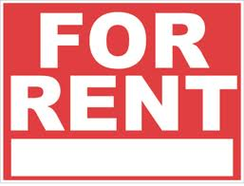
If you rent an apartment in the Village of Birch Run, please refer to your lease regarding garbage and recycling collection. Not all apartments have curbside garbage or recycling pick up.
Home Improvements
Homeowners should assume permits are required for all home improvements. Please call the Building/Zoning administrator at (989) 624-5711 before improvements are made. Permit applications and ordinances can be found on the Village’s website.
Useful Ordinances

Anti-Blight
- Property owners are responsible for maintaining their house and yard to safety and appearance standards.

Weed, Tall Grass and Tall Brush Control
- Starting May 1st of each year homeowners are required to remove all tall weeds and grass from their property and the right of way in front of their property. Tall weeds and grass is anything over 9”.
- Burning yard waste, garbage, refuse, and/or combustible material is prohibited in the Village of Birch Run.

Traffic Control
- Parking between the hours of 3 a.m. and 7 a.m. is prohibited on all streets and in Village owned parking lots.

Animals
- The Village does not license dogs or cats, but Saginaw County requires registration of dogs. It is unlawful to permit any dog to run at large in the Village. Please be considerate of your neighbor when having a dog. Saginaw Animal Control can be reached at (989) 797-4500.



Home of the Panthers!
Birch Run Area Schools:
Administration
(989) 624-9307
Birch Run High School
(989) 624-9392
Marshall Greene Middle School
(989) 624-5821
North Elementary School
(989) 624-9011
www.birchrun.k12.mi.us
Useful Information
Birch Run Fire Department:
(989) 624-9561
Birch Run Herald:
1-800-352-1919
Birch Run Police
(989) 624-1113
Birch Run Township:
(989) 624-9773
Chamber of Commerce:
(989) 624-9193
Consumer’s Energy:
1-800-477-5050
Fleschner Memorial Library:
(989) 624-5171
U.S. Post Office:
(989) 624-5324
Saginaw County Treasurer:
(989) 790-5225
www.saginawcounty.com

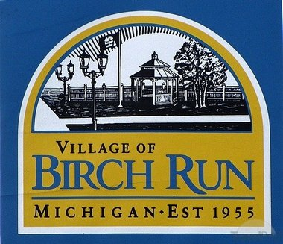

Village of Birch Run
12060 Heath Street
P.O. Box 371
Birch Run, Michigan 48415
Phone (989) 624-5711
Fax (989) 624-9681

Village Office Hours
Monday-Thursday 8-12; 1-5
Friday 8-4
www.villageofbirchrun.com
Visit us on Facebook

Vision Statement
The Village of Birch Run is a community that is beautiful, historic, culturally diverse, affordable, safe, and well planned with great opportunity for our citizens.


